School for Wee Ones
301 Gospel Rd. Charlestown, IN
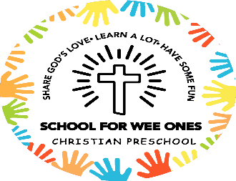
502-415-3438

Welcome to School for Wee Ones! We are very happy that you have decided to enroll your child for the 2026/2027 school year!

Please return all enrollment forms with the $100 registration fee.

A copy of your child’s birth certificate and most current shot records will be required before school begins in August.

If you have any questions, you can call or text School for Wee Ones at 502-415-3438 or you can email us at schoolforweeones@gmail.com

We look forward to teaching your child next year!

